# NETWORKING & SYSTEM ADMINISTRATION LAB

**Name: MELBIN M P**

**Roll No: 19**

**Batch: S2 RMCA B Date: 25-04-2022**

**Experiment No: 7**

# Aim

Familiarization of linux commands.

# Procedure

1. $ sudo useradd <username>

This command is used to adding/creating user accounts in linux. Output:



1. $ sudo passwd <username>

This command sets password for the users Output:

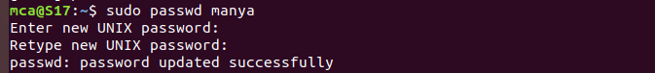

1. $ sudo groupadd -g <identifier><groupname>

It creates a new group account using the values specified. Output:



1. $ sudo username -G <groupname><username> This command adds the users to the specified groups Output:



1. $ id <username>

It is used to find out user and group names and numeric id

Output:



1. $ compgen -g

To display the names of groups Output:

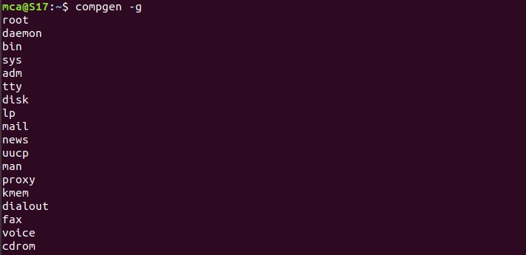

1. userdel

It is used to delete a user account and related files.

$ sudo userdel <username> Output:



1. groupdel

It is used to delete a existing group. Output:



1. $ compgen -g <groupname>

List the specific group which is specified in the command. Output:



1. chmod

This chmod command is used to change the access permissions of files and directories. It stands for change mode.

The file permissions-read(r), write(w), execute(x).

$ chmod <options><permissions><filename>

1. To give read, write and execute permissions.



1. To denied the write and execute permissions to the file.



1. chown command

It is used to change a file ownership, directory or symbolic link for a user or group. The Chown stands for change owner.

Chown[option]….[owner][:[group]]file Output:



1. ifconfig

Interface configurator, we can view ip address, MAC address and MTU(maximum transmission unit)with ifconfig command.

Output:

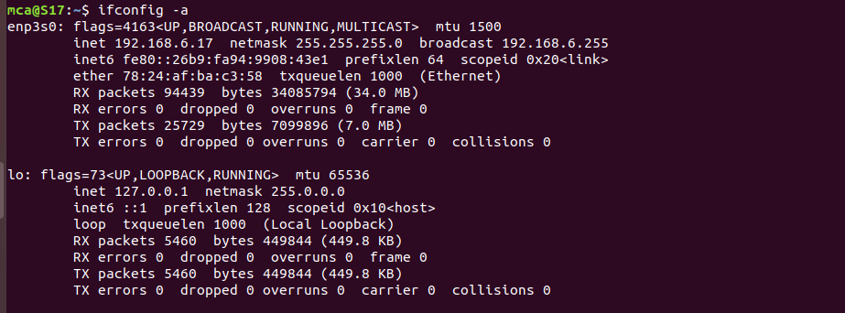

1. ssh command

It stands for secure shell or secure socket shell. ssh user-name @ host(ip/Domain-name)

ssh command: It instructs the machine to create a secure encrypted connection with the host system.

Username: name of user which is being accessed by the host. Host: It is a machine that is being accessed by the user.

Output:

